Password cracking using Pwdump7 and Ophcrack
Course Name: FRS301-Digital Forensics
Student Name: Nguyễn Trần Vinh – SE160258
Instructor Name: Lê Tiến Dũng
Lab Due Date: 17/2/2023

- Introduction
In this experiment, we use Windows 7 and Windows 10 together with Pwdump7 and Ophcrack. There are a lot of users set up on the Windows 7 platform. Using managed access, we will access the encrypted hashes and forward them to the Windows 10 platform containing Ophcrack to crack the password.
- Preparation
https://www.tarasco.org/security/pwdump_7/
https://ophcrack.sourceforge.io/download.php
Computer running windows operating system 7, 10, disable virus and firewall
- Implementation steps
- Go to Windows 7 machine and run Command Prompt with administrative privileges.
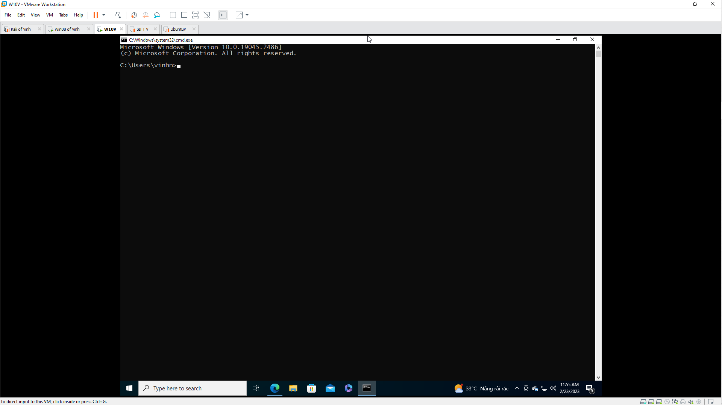

- Input command below :
C:\Users\Win7-1>wmic useraccount get name, sid
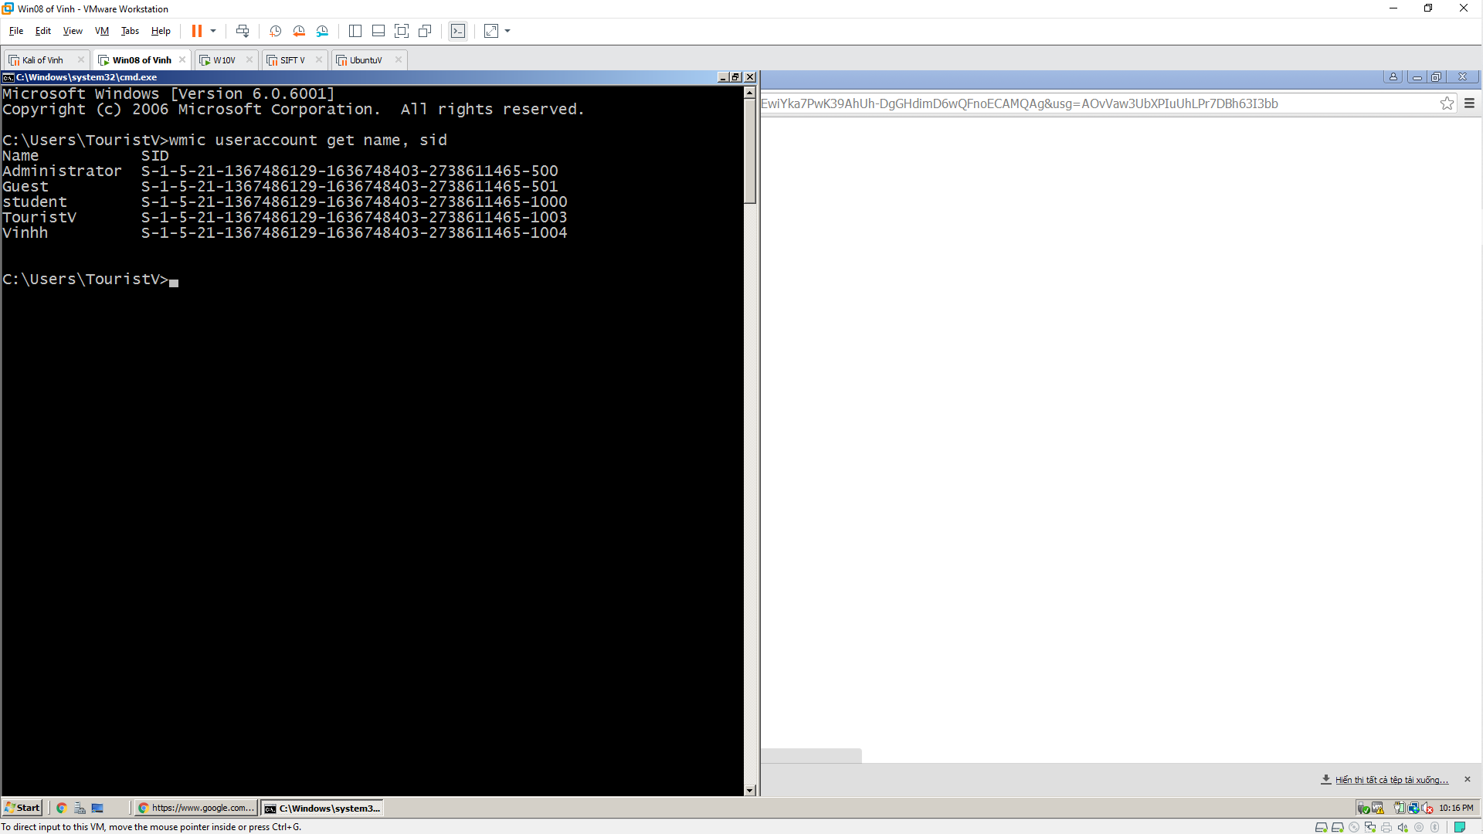
- Go to the directory containing pwdump7 and run the application. In our case pwdump7 is located on the desktop.
C:\Users\Win7-1\Desktop\pwdump7>pwdump7.exe
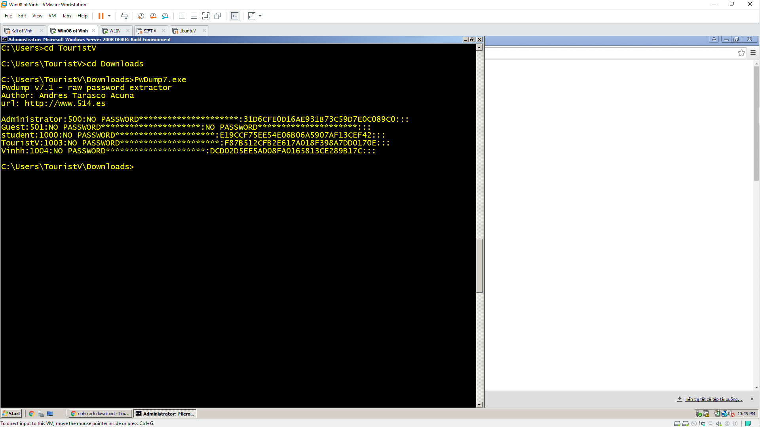
- Copy the result to a text file using the command:
pwdump7.exe > C:\Users\Win71\Desktop\Hashes.txt
- Check the Hashes.txt file on the desktop.

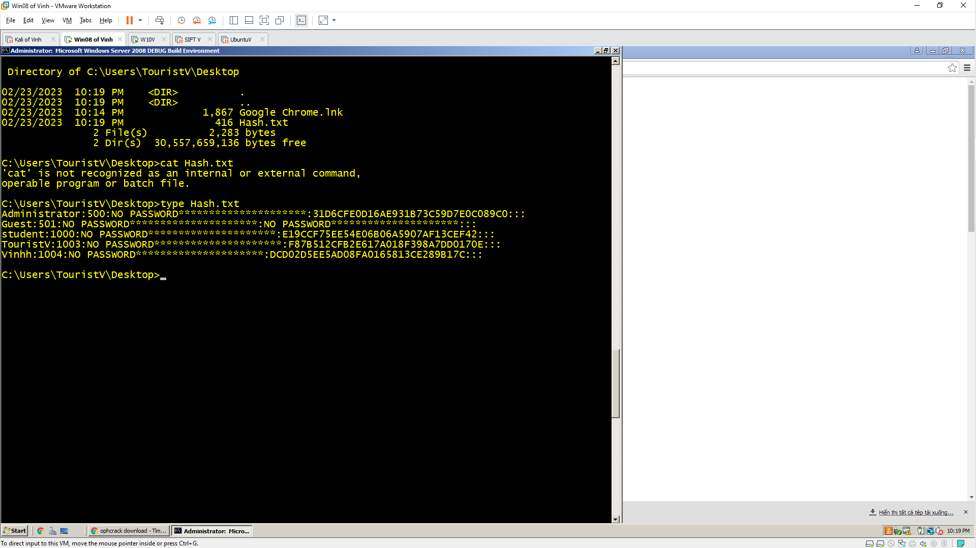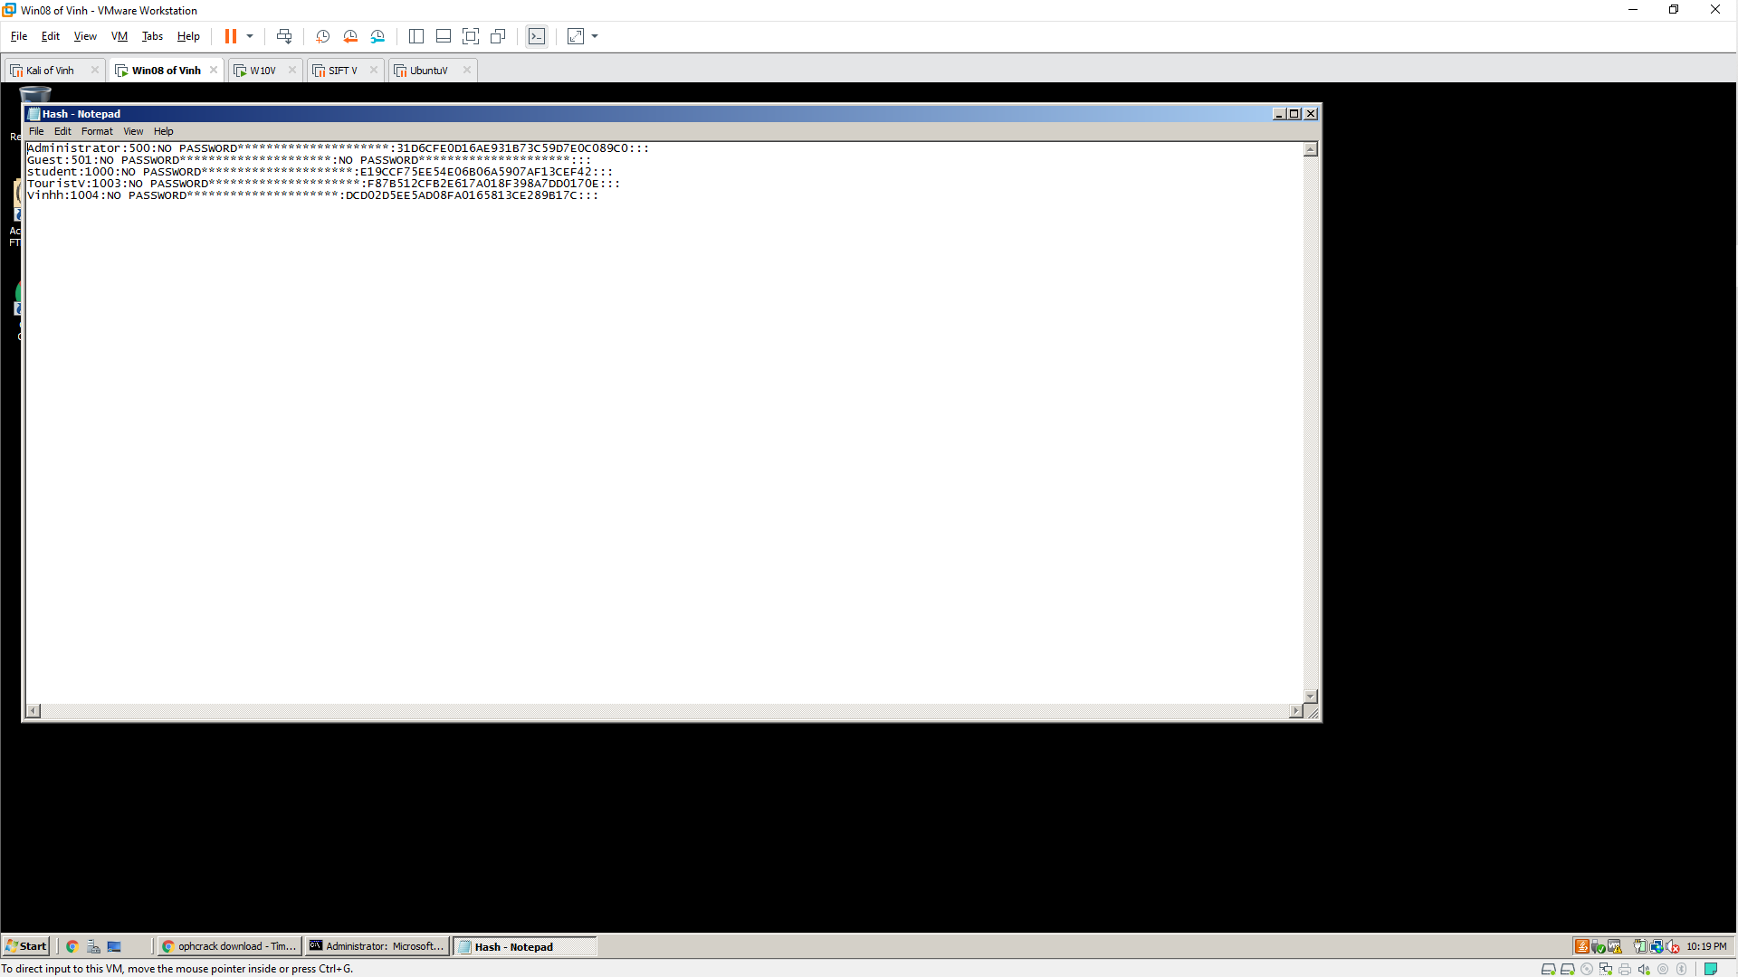
- Transfer files to a remote machine (Windows 10). You can also install Ophrack on the same machine.
- Run Ophrack on Windows 10 platform.
- Click Load \ select PWDUMP File
- Hashes have been loaded in the application as shown below.
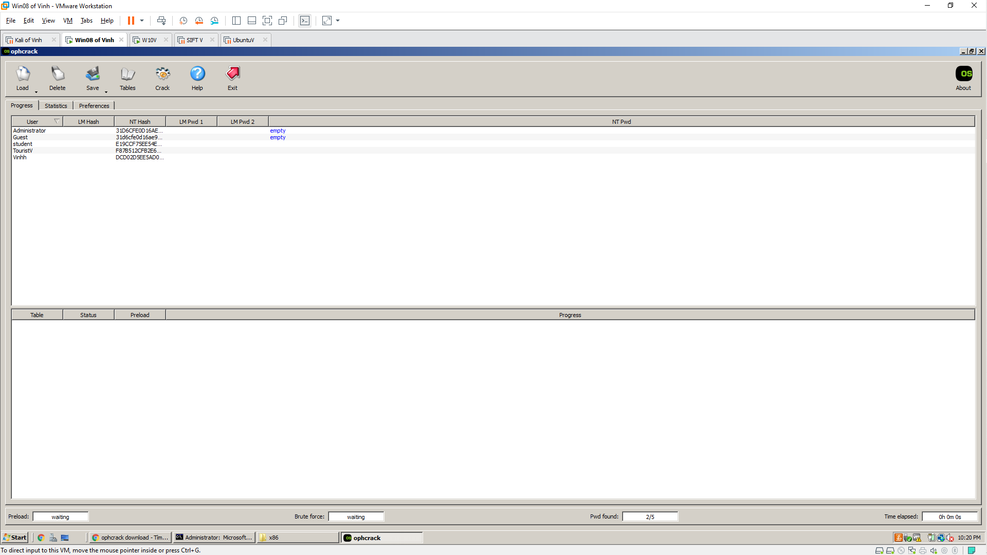
- Click the Table button to load/insert the table.
- Select table. In this case, we choose Vista free table.
- Select and press Install.
- Choose a location for the folder containing the table. We use the default table of the application so the folder is in the same location as the application.
- Click Ok
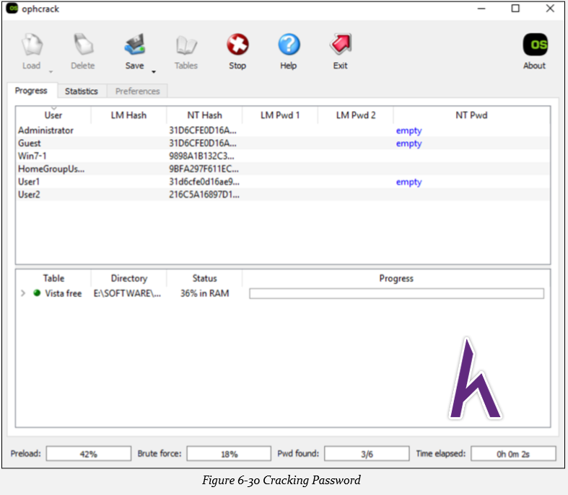
- Press the Crack button to start the jailbreak.
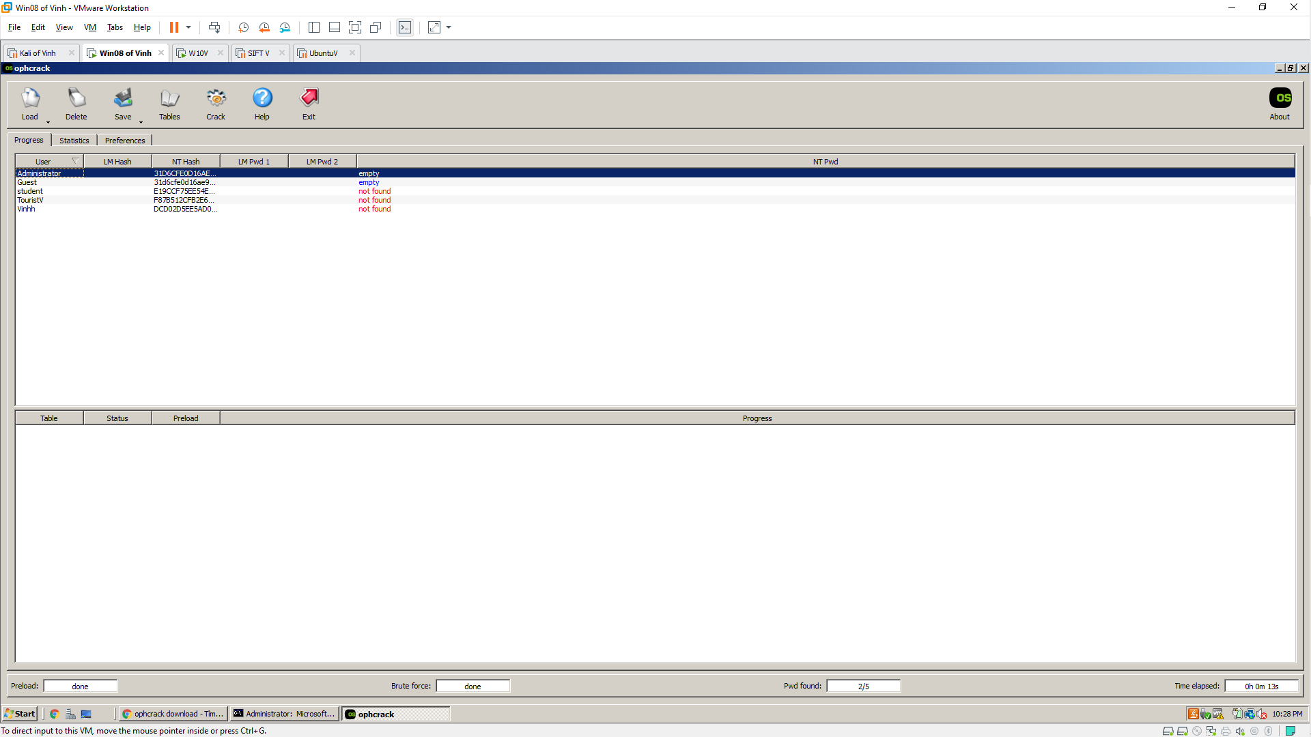
- The results show that the user does not set a password, the user with a cracked password. In the result there may be uncracked passwords, you can try other tables to crack.

